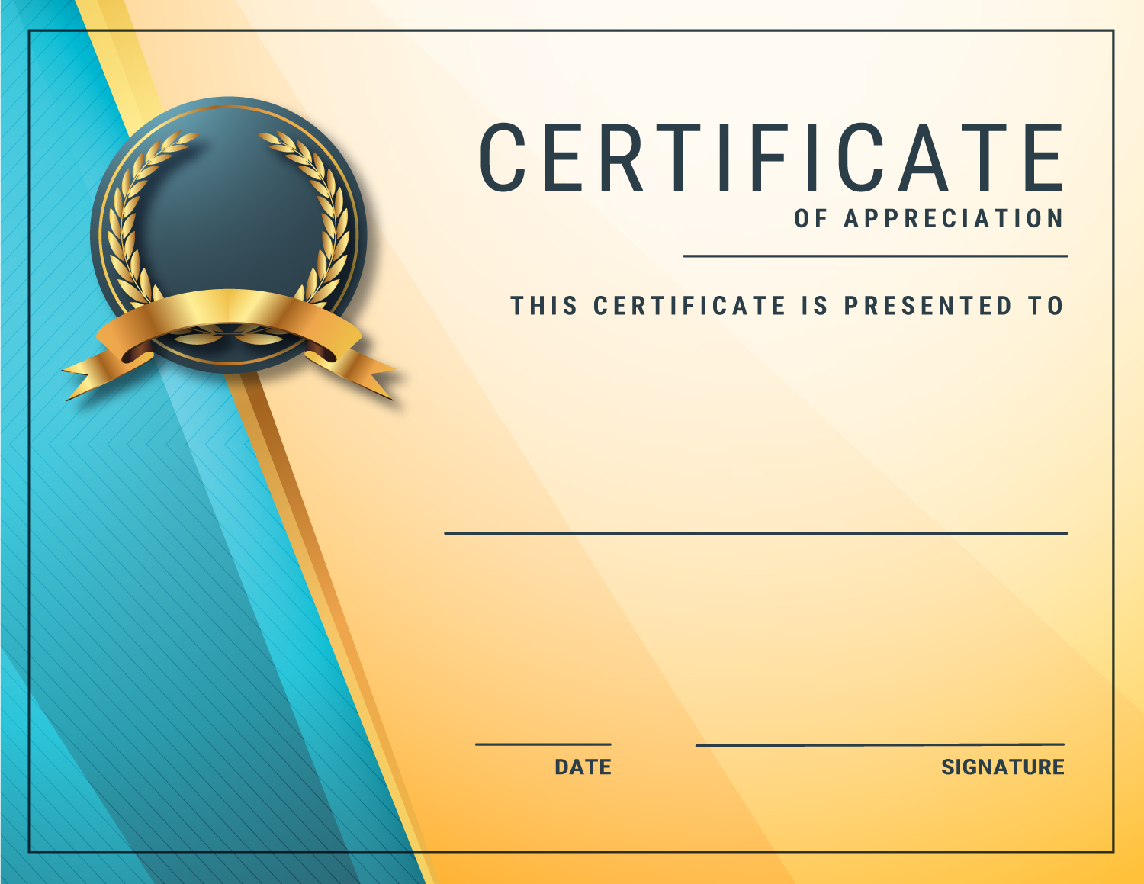

Name Surname

Lorem ipsum dolor sit amet, lorem ipsum dolor sit amet

lorem ipsum dolor sit amet lorem ipsum dolor sit amet lorem ipsum dolor sit amet,lorem ipsum dolor sit amet dolor sit amet,lorem ipsum dolor sit.

Lorem ipsum dolor sit amet